**INDUSTRY / RESEARCH INTERNSHIP**



**An**

**Internship Report Submitted To**

### VISVESVARAYA TECHNOLOGICAL UNIVERSITY

**Belagavi, Karnataka**

*For The Award of Degree*

***Bachelor of Engineering***

By

**Mr.** **Saqib Z Bagsiraj**

**USN: 2JI22CS053**

Guide

**Prof. Manjula Patil**

Professor

Department of Computer Science and Engineering

Jain College of Engineering, Belagavi



**Department of Computer Science and Engineering JAIN COLLEGE OF ENGINEERING (JCE)**

**Belagavi, Karnataka – 590014 2024-2025**

**JGI’s**

# JAIN COLLEGE OF ENGINEERING (JCE)

## BELAGAVI



**DEPARTMENT OF COMPUTER SCIENCE AND ENGINEERING**

**Certificate**

Certified that **Mr. Saqib Z Bagsiraj,** an undergraduate student bearing **USN 2JI22CS053** has satisfactorily completed the **Internship** on **“FullStack Development”, at Test Yantra Software Solutions (India) Private Limited (Q-spiders)** submitted to **Visvesvaraya Technological University, Belagavi** in partial fulfillment for the award of **Bachelors** in **Computer Science and Engineering.**

**Guide Internship Co-ordinator Principal & Director**

# Visvesvaraya Technological University, Belagavi



## CERTIFICATE

**Certified that the Industry Internship**

**“FullStack Development”**

is a bonafide work carried out by

**Mr. Saqib Z Bagsiraj USN: 2JI22CS053**

*In partial fulfillment for the award of* **BACHELORS IN COMPUTER SCIENCE AND ENGINEERING** *of the* ***Visvesvaraya Technological University, Belagavi.*** *The report has been approved as it satisfies the academic requirements in respect of Internship Work prescribed for the said degree*

**Name of the Examiners Signature with date**

## Internship Certificate

**Acknowledgements**

I am grateful and would like to express my sincere gratitude to guide Prof. Manjula Patil for his untiring guidance, continuous encouragement and constant support which made this Internship study possible. Sir has impressed me with his outstanding professional conduct and his strong conviction towards the Internship study. I am truly obliged for his progressive vision throughout the internship.

I would also like to thank Principal and Director of Jain College of Engineering, Belagavi Dr. J. Shivakumar, HOD Computer Science and Engineering, Dr. Uttam Patil, Faculty of Computer Science and Engineering Department and Management of Jain College of Engineering, Belagavi, for their wisdom and valuable suggestions during my internship work. I extend my gratitude to the, Internship Co-ordinator and Staff of Jain College of Engineering, Belagavi, for their support and cooperation during the study.

I finally acknowledge my sincere indebtedness and gratitude to my parents and family for their constant support and encouragement throughout the Internship.

Saqib Z Bagsiraj

### ABSTRACT

The Industry Internship provided valuable practical exposure to real-world software development processes and industry practices. It offered an opportunity to apply academic knowledge in a professional environment and gain hands-on experience in full-stack web application development. During the internship, I worked on designing, developing, and deploying a complete project using modern technologies such as React.js, Node.js, Express.js, and MongoDB.

The internship enhanced my understanding of end-to-end software development, including frontend design, backend API creation, database management, and real-time data handling. I also learned about project planning, teamwork, version control (Git/GitHub), and deployment techniques. The experience helped strengthen both technical and soft skills, such as problem-solving, collaboration, and communication.

Overall, the industry internship served as a bridge between theoretical learning and practical implementation, providing a strong foundation for future professional growth in the field of full-stack development and modern software engineering.

### 

**TABLE OF CONTENTS**

**CONTENTS Page No.**

|  |  |
| --- | --- |
| Acknowledgement |  |
| Abstract | i |
| Table of Contents | ii |
| List of Figures | v |
| List of Tables | xii |
| List of Abbreviations | xvii |

**Chapter 1: Industry Internship 1-6**

* 1. : Introduction 1
  2. : Objectives of Internship 4
  3. : Report Outline 5

**Chapter 2: Industry / Company Profile 6-20**

* 1. : Firm History 6
  2. : Management Board of the Firm 8
  3. : Vision & Mission 12
  4. : Products / Services 16
  5. : Employees and their experiences 20

**Chapter 3: Job Description & Internship Experience 21-35**

* 1. : Project Description 21
  2. : Software / Hardware / Design Development Process 24
  3. : Project Planning & Execution 28
  4. : Implementation, Testing & Documentation 31
  5. Deployment and Maintenance 32
  6. Images (field images of Internships with GPS) 34

**Chapter 4: Internships Learning’s & Findings** **36-50**

* 1. : Types of Team / Department in the Firm 36
  2. : Hierarchy of Roles / Posts in the Firm 38
  3. : Challenges Involved in the Firm 40
  4. : Opportunities in the Firm 44
  5. : Tools and Techniques Acquired 46
  6. : Observations & Evaluation 48
  7. : Conclusion 50

**Chapter 5: Appendix 51-60**

* 1. : Letter of Application to the Organization 51
  2. : Letter of acceptance by the Organization 52
  3. : Declaration & Undertaking 53
  4. : Attendance Sheet 55
  5. : Evaluation Sheet by the organization 57

### LIST OF FIGURES

|  |  |  |
| --- | --- | --- |
| **Figure No.** | **Description** | **Page No.** |
| Figure 3.1 | The Project workflow | 26 |
| Figure 3.2 | The Project Schema | 26 |
| Figure 3.3 | Dashboard of the project | 30 |
| Figure 3.4 | Holdings chart and current value analysis | 31 |
| Figure 3.5 | Positions list | 39 |
| Figure 3.6 | Adding funds and withdrawing funds | 40 |

### LIST OF TABLES

|  |  |  |
| --- | --- | --- |
| **Table No.** | **Description** | **Page No.** |
| Table 3.1 | Roles and responsibility of Users | 32 |
| Table 3.2 | Software and hardware layer and Technologies used | 32 |
| Table 3.3 | Feature and description | 54 |
| Table 3.4 | Challenge and solution | 55 |
| Table 3.5 | Maintenance and description | 58 |

### Abbreviations

|  |  |
| --- | --- |
| **Parameter** | **Description** |
| FSD | Full Stack Development |
| BOM | Bill Of Materials |
| DB | Data base |
| MONGODB | NOSQL database |
| HTML | Hyper Text Markup Language |
| CSS | Cascading Style Sheets |
| JS | Java Script |
| UI | User Interface |
| AI | Artificial Intelligence |
| UX | User Experience |
| DIR/DIRS | Directory/Directories |
| ERP | Enterprise Resource Planning |

### Chapter-1

### Industry Internship

* 1. **Introduction**

Industry internship is an important part of the engineering curriculum that bridges the gap between academic learning and real-world working environments. It provides students with exposure to professional practices, organizational workflow, team collaboration, and practical problem-solving.  
During the internship, students get an opportunity to apply technical knowledge gained in the classroom to real-life projects and industry-level challenges. This experience helps in developing professional skills such as communication, teamwork, time management, and project execution.  
The internship also helps students understand the latest tools, technologies, and methodologies used in the industry and prepares them for future employment opportunities.

* 1. **Objectives of Internship**

The main objectives of the internship are:

* To gain practical exposure and hands-on experience in **Full Stack Development**.
* To understand the workflow, structure, and professional culture of the organization.
* To apply theoretical knowledge to real-time applications and project development.
* To learn and use various development tools, frameworks, and platforms.
* To enhance problem-solving, debugging, and project deployment skills.
* To improve teamwork, communication, and documentation abilities.
* To identify personal strengths and areas for improvement for future career development.
  1. **Report Outline**
* **Chapter 1** provides an introduction to the internship, its objectives, and the structure of the report.
* **Chapter 2** describes the company profile, including its history, vision, mission, services, and organizational structure.
* **Chapter 3** includes the job role, project details, software development process, and implementation carried out during the internship.
* **Chapter 4** covers the learnings, observations, challenges faced, and skills acquired during the internship.
* **Chapter 5** consists of supporting documents such as offer letter, attendance sheet, and evaluation forms.

### Chapter-2

### Company Profile

* 1. **Firm History**
* Founding & Legal Status: QSpiders was established under the Test Yantra ecosystem by Girish Ramanna with the goal of delivering industry-focused training in software testing and development. It operates as a professional training and placement institute under **Test Yantra Software Solutions (India) Private Limited**, a registered private-limited company. The institute functions within a structured corporate framework, emphasizing skill enhancement and employability for aspiring IT professionals.
* Purpose & Early Activities: QSpiders was created to bridge the gap between academic learning and real-world IT requirements by providing practical training and placement opportunities. In its early years, it focused on offering specialized programs in software testing, Java development, and related technologies.
  1. **Management Board of the Firm**
* Girish Ramanna— Chairman, Q spider
* Girish Ramanna — Managing Director
* Keshav Eara — Director
  1. **Vision & Mission**
* **Vision**: QSpiders envisions empowering learners with industry-ready technical skills through practical, high-quality training. It aims to become the most trusted global platform for transforming students into skilled IT professionals.
* **Mission**:

1. Incubate startups, creating jobs.

2.Train students and faculty in entrepreneurship and emerging technologies.

3.Facilitate patent filings through collaborative research.

4.Develop community-focused solutions

* 1. **Products / Services**
* **Incubation & Start-up Support**

○ Short‑term and extended incubation (example: structured 16‑month free incubation offerings), mentoring, co‑working space facilitation, and non‑dilutive support services.

**● Mentorship & Industry Linkages**

* One‑on‑one mentoring by faculty, alumni entrepreneurs, and external experts; introductions to accelerators and partner incubators.

**● Training & Capacity Building**

* Workshops and certificate programs on entrepreneurship, product development, digital marketing, fundraising, technical upskilling, and soft skills for founders.

**● Collaborations & Formal Agreements**

* MoUs and partnership frameworks with national incubators, industry players, and academic bodies to provide structured opportunities for startup.

**● Consultancy & Advisory Services**

* Support for startup proposals, grant applications (state / central schemes), business model consulting and preparation of incubation/TBI proposals.

### Chapter-3

### Job Description & Internship Experience

* 1. **Project Description**

The **Hotel Appointment System** is a full-stack web application designed to manage room bookings, customer details, and check-in/check-out operations efficiently. It allows users to view available rooms, create appointments, and track their booking status in real time. Administrators can manage rooms, customers, and booking records through a secure and user-friendly dashboard. Built using React.js, Node.js/Express, and MySQL, the system ensures fast performance and reliable data management.

The system supports **Two user roles**:

| **Role** | **Responsibilities** |
| --- | --- |
| **Designer** | Created the visual layout and user interface for the Hotel Appointment System, ensuring a clean, modern, and user-friendly design. |
| **Developer** | |  | | --- | |  |  |  | | --- | | Built the complete system using React.js, Node.js, and MySQL, implementing features like room booking, customer management, check-in/check-out, and secure authentication. | |

Table 3.1

The system ensures **role-based access**, data consistency, and real-time notification updates when work orders are created/updated.

* 1. **Software / Hardware / Design Development Process**

| **Layer** | **Technologies Used** |
| --- | --- |
| **Frontend** | React , CSS, HTML |
| **Backend** | Node.js, Express.js |
| **Authentication** | JWT Token-based Authentication |
| **Version Control** | Git & GitHub |
| **Development Environment** | VS Code |

Table 3.2

* 1. **Project Planning & Execution**

**The project overview and objectives:**

### The Hotel Appointment System is a web-based application designed to simplify and automate the process of room booking and customer management in hotels. The system enables staff to manage rooms, handle appointments, maintain customer records, and process check-in/check-out operations through an intuitive dashboard. Built using React.js, Node.js, and MySQL, the application ensures efficient data handling, smooth navigation, and a modern user experience.

### ****Objectives****

* To provide a simple and efficient platform for managing hotel room appointments.
* To automate customer record handling and reduce manual paperwork.
* To enable quick check-in/check-out operations with real-time updates.
* To ensure secure data access using authentication and role-based control.
* To improve hotel productivity by offering a user-friendly digital management system.

**Project flow:**

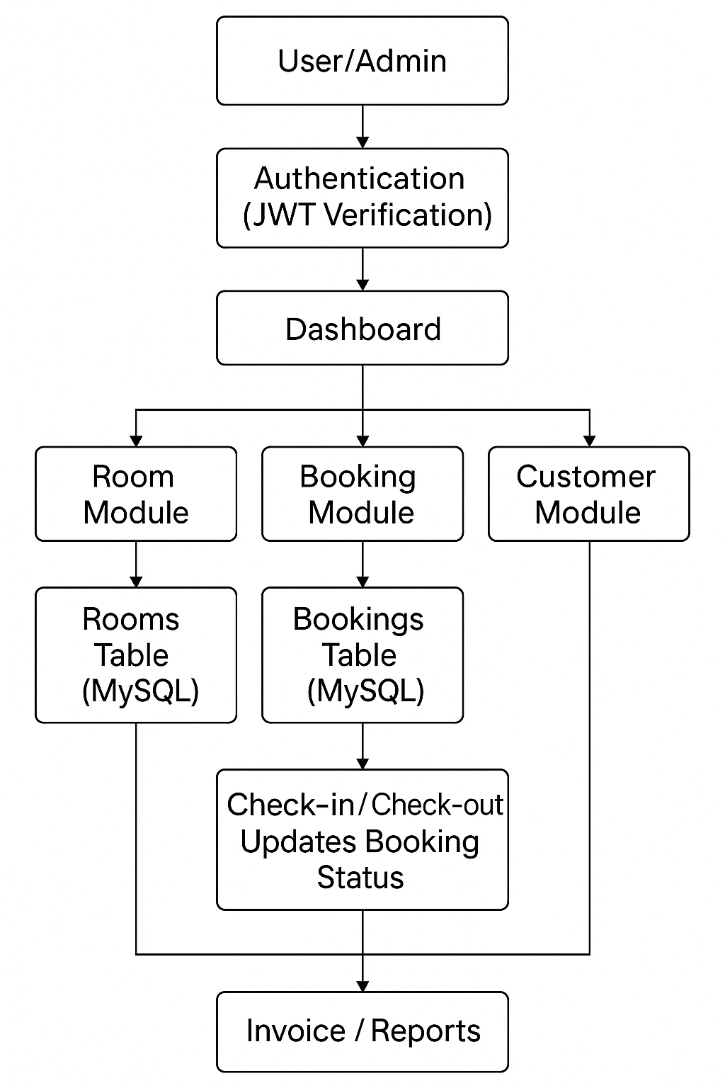

Figure 3.1

**Project Schema:**

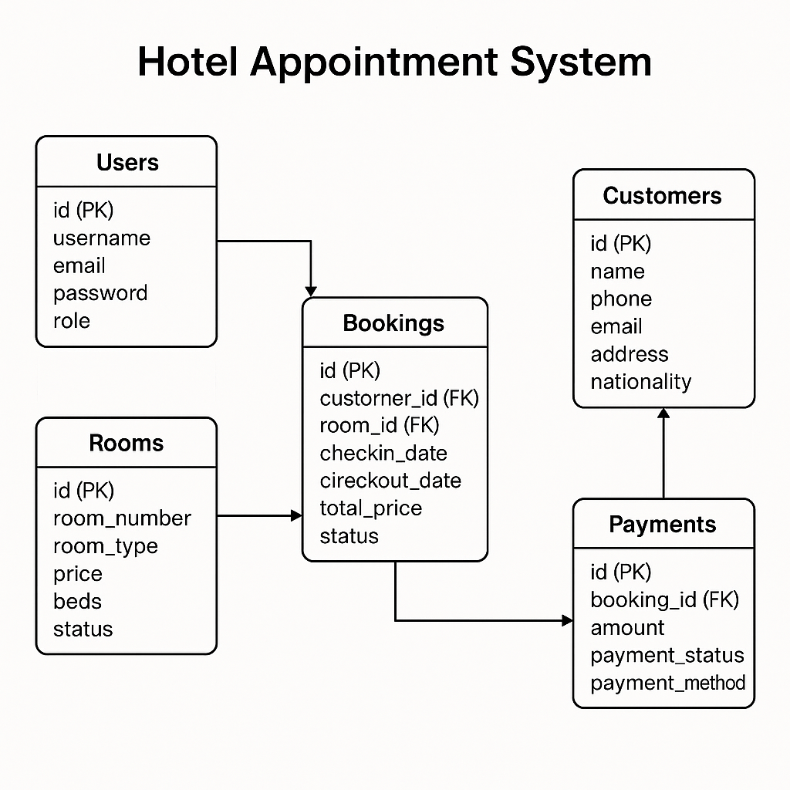

Figure 3.2

**Execution Steps:**

• **Requirement Analysis:**

* Collected functional requirements and identified user roles (Admin and Trader).
* Defined key features: room booking, customer management, check-in/check-out, authentication, and invoice generation.

• **Technology Selection:**

Selected **React.js** for the frontend, **Node.js + Express.js** for the backend, and **MySQL** for the database

• **System Design:**

* Designed the overall system architecture and data flow diagram.
* Created database schema for users, rooms, bookings, and payments.
* Planned REST API endpoints for room management, booking operations, and authentication..

• **Frontend Development:**

* Built responsive UI using **React.js and CSS.**
* Developed pages like login, dashboard, room list, booking form, customer list, and check-in/check-out.
* Implemented React Router for navigation and Axios for API requests.

• **Backend Development:**

* Developed RESTful APIs using **Node.js** and **Express.js**.
* Implemented **JWT authentication** for user login and authorization.
* Integrated with **MySQL** to manage user and transaction data.

• **Booking & Room Management Logic:**

* Implemented dynamic room availability checking
* Added logic for creating, updating, and canceling bookings.

• **Testing and Debugging:**

* Performed manual and API testing using Postman.
* Debugged issues related to authentication, routing, and database consistency.

• **Deployment:**

* Deployed **frontend** on **Render**.
* Deployed backend on Render/Railway and connected it with MySQL database.
  1. **Implementation, Testing & Documentation**

| **Feature** | **Description** |
| --- | --- |
| **User Authentication** | Login system with secure local token storage |
| |  | | --- | | **Room Management** |  |  | | --- | |  | | Admin can add, update, or delete rooms with details like type, price, beds, and availability. |
| |  | | --- | | **Booking & Appointment System** |  |  | | --- | |  | | Staff can create, update, or cancel room appointments. System automatically checks room availability and prevents double-booking. |
| |  | | --- | | **Customer Management** |  |  | | --- | |  | | |  | | --- | | Stores and manages customer details such as name, phone, email, and address. |  |  | | --- | |  | |
| |  | | --- | | **Check-in / Check-out** |  |  | | --- | |  | | Allows staff to handle customer check-in/check-out and updates booking status in real time. |
| |  | | --- | | **Invoice Generation** |  |  | | --- | |  | | |  | | --- | | Automatically generates invoice details including room charges, duration, and total price. |  |  | | --- | |  | |
| |  | | --- | | **Payments Management** |  |  | | --- | |  | | |  | | --- | | Records booking payments, payment status, and method (Cash/UPI/Card). |  |  | | --- | |  | |
| |  | | --- | | **Responsive Web Interface** |  |  | | --- | |  | | |  | | --- | | Built with React.js and optimized for mobile, tablet, and desktop screens. |  |  | | --- | |  | |

Table 3.3

| **Challenge** | **Solution** |
| --- | --- |
| |  | | --- | | Integrating Real-Time Room Availability |  |  | | --- | |  | | |  | | --- | | Implemented dynamic availability checks in the backend and synchronized booking status updates across all modules. |  |  | | --- | |  | |
| |  | | --- | | Managing Role-Based Access and Secure Authentication |  |  | | --- | |  | | |  | | --- | | Used JWT-based authentication with middleware to restrict access for Admin and Staff users. |  |  | | --- | |  | |
| |  | | --- | | Handling Overlapping or Double Bookings |  |  | | --- | |  | | |  | | --- | | Added server-side validation to prevent booking conflicts and ensure only available rooms can be reserved. |  |  | | --- | |  | |
| |  | | --- | | Maintaining Accurate Customer & Booking Records |  |  | | --- | |  | | |  | | --- | | Implemented relational database design (MySQL) with proper foreign keys and cascading updates. |  |  | | --- | |  | |

Table 3.4

* 1. **Deployment and Maintenance**

After the development and testing phases, the next step was to deploy the **Hotel Appointment System** so that it could be accessed and used by Admin and Staff users over the network. The deployment process ensured that both the frontend and backend components were hosted on reliable platforms, the MySQL database was properly configured, and all system functionalities worked smoothly in the live environment.

**Deployment Process:**

The deployment was carried out in the following steps:

• **Environment Preparation:**

* Installed all required dependencies for both frontend and backend using **npm install**.
* Configured environment variables (API keys, database URIs, JWT secret, and ports) in .env files.
* Ensured both servers (React frontend and Node backend) worked properly in the local environment.

• **Database Deployment:**

* Created a **MySQL database** on a hosting service (e.g., ClearDB, Railway, or local MySQL server).
* Created required tables: **Users, Rooms, Bookings, Customers, Payments**.
* Configured secure database connection strings inside the backend environment.

• **Backend Deployment:**

* Deployed the backend (Node.js + Express.js) on **Render** or **Heroku**.
* Connected backend APIs with MySQL.
* Tested API endpoints (Login, Register, Buy/Sell, Predict) using **Postman** to confirm functionality.

• **Frontend Deployment:**

* Built the production version of the React app using:
* npm run build
* Deployed the build folder to **Render** or **Netlify**.
* Updated API base URLs in the frontend to point to the live backend server.

• **Integration Testing:**

* Tested full system flow from Login → Room Selection → Booking Creation → Check-in/Check-out → Invoice Generation.
* Verified that frontend and backend communication worked correctly using live APIs.
* Ensured CORS and authentication were configured properly.

• **Monitoring and Maintenance:**

* Monitored server logs and performance through Render/Vercel dashboards.
* Fixed minor deployment bugs and ensured continuous uptime.
* Regularly updated dependencies and environment configurations for security and performance.

**Maintenance:**

Maintenance is essential to ensure the system continues to operate smoothly, securely, and efficiently. The key maintenance tasks performed include:

| **Maintenance Task** | **Description** |
| --- | --- |
| **Bug Fixing** | Any issues reported during usage were traced, debugged, and resolved. |
| **Performance Monitoring** | Monitoring API response time, database query speed, and server load to optimize performance. |
| **Database Maintenance** | Ensuring database indexes are optimized and backups are regularly verified. |
| **Security Updates** | Updating npm packages, fixing vulnerabilities, and rotating security keys when needed. |
| **User Support** | Helping users understand functionality and resolving login/data access issues. |
| **Feature Improvements** | Enhancing features based on feedback from Traders. |

Table 3.5

* 1. **Images (Result)**

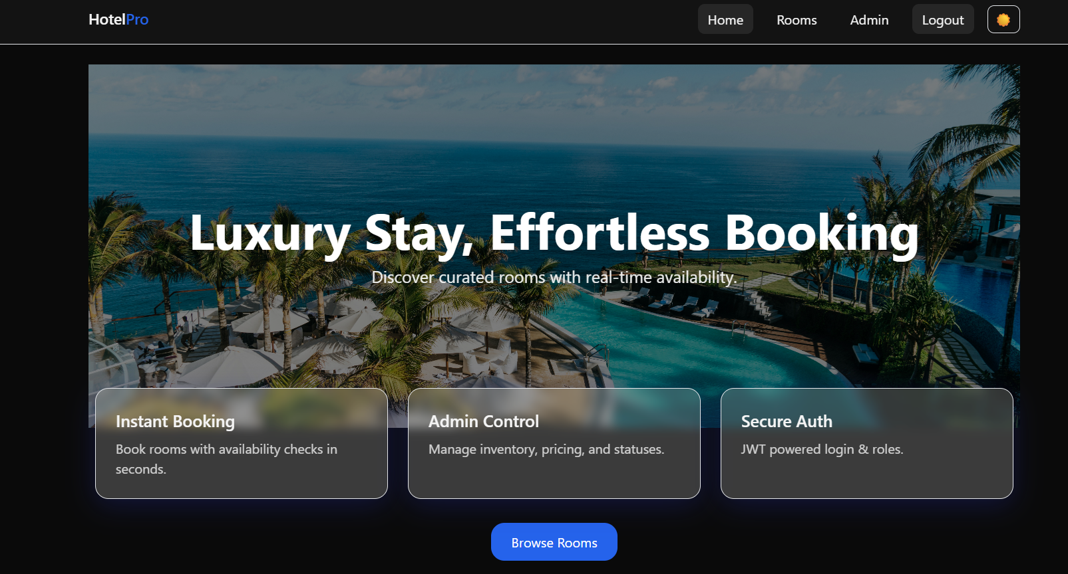

**Figure 3.3**

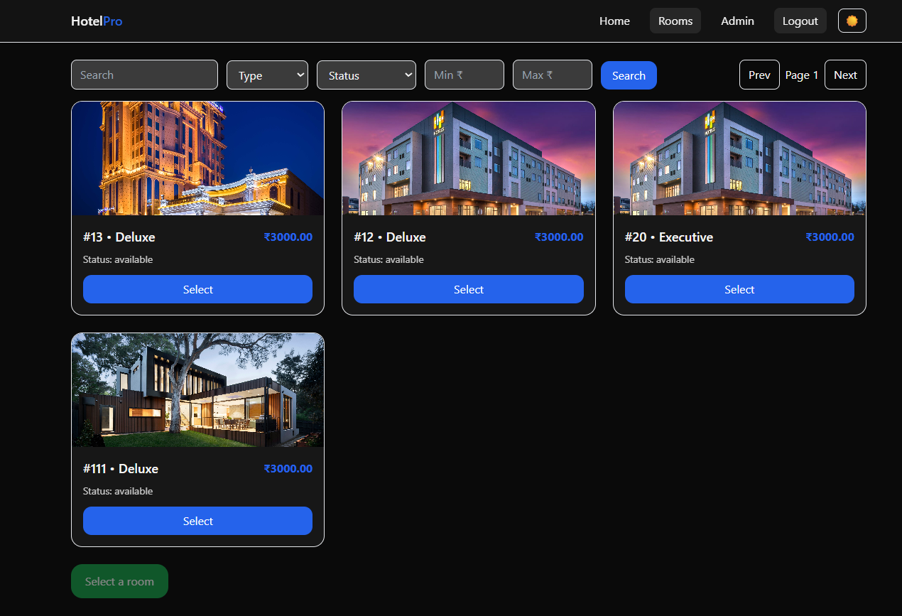

**` Figure 3.4**

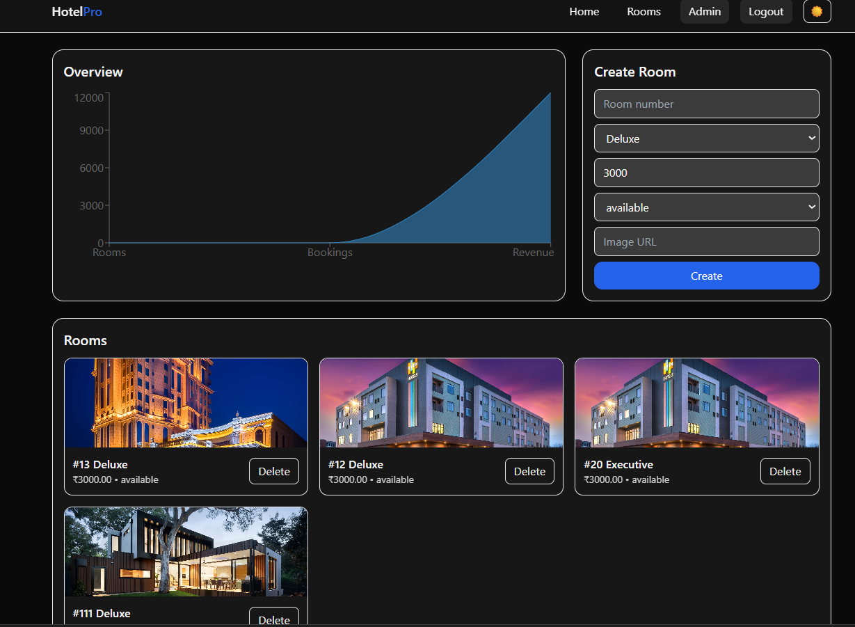

**Figure 3.5** 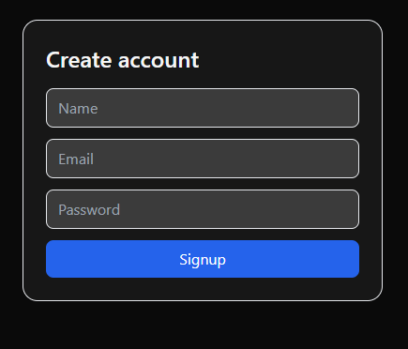

**Figure 3.6**

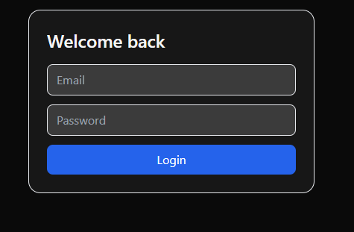

**Figure 3.7**

### Chapter-4

### Internships Learning’s & Findings

### 4.1 Types of Teams / Departments in the Firm

In a professional firm or organization, departments are usually divided based on functional specialization to ensure efficiency and smooth workflow. Common departments include:

* **Management & Administration**: Handles strategic planning, decision-making, policy formulation, and coordination among departments.
* **Finance & Accounts:** Manages financial records, budgeting, payroll, and audits.
* **Human Resources (HR):** Responsible for recruitment, training, performance management, and employee welfare.
* **Marketing & Public Relations:** Focuses on branding, promotions, social media engagement, client communication, and event coordination.
* **Research & Development (R&D):** Works on innovation, new product development, and continuous improvement.
* **Operations / Production:** Ensures day-to-day business functions, quality control, and service delivery.
* **IT & Technical Support**: Provides technical assistance, maintains software/hardware systems, and ensures data security.
* **Customer Support / Service:** Handles client or customer queries, complaints, and after-sales support.

Each team functions collaboratively toward achieving organizational goals through structured workflows and interdepartmental coordination.

**4.2 Hierarchy of Roles / Posts in the Firm**

Organizations follow a hierarchical structure to ensure clarity of roles, accountability, and communication. The typical hierarchy includes:

* **Top Management**: Board of Directors, Managing Director — responsible for vision, mission, and strategic decisions.
* **Middle Management**: Department Heads, Managers — responsible for planning, coordination, and supervision.
* **Supervisory Level:** Team Leaders, Project Leads — oversee day-to-day execution and guide junior staff.
* **Operational / Executive Level:** Executives, Engineers, Interns — carry out assigned tasks, reports, and contribute directly to deliverables.

During internships, students usually operate at the executive or trainee level, learning reporting systems, team dynamics, and professional communication.

**4.3 Challenges Involved in the Firm**

Every firm faces operational and strategic challenges that provide valuable learning experiences. Some common challenges include:

* + **Time Management:** Balancing multiple projects with limited resources.
  + **Adapting to Work Culture:** Understanding organizational norms and adjusting to professional expectations.
  + **Technology & Skill Gaps:** Keeping up with evolving tools, platforms, and technical demands.
  + **Client Management:** Handling deadlines, requirements, and maintaining professional relationships.
  + **Innovation Pressure:** Continuous need to innovate and stay competitive in the market.

For interns, these challenges enhance adaptability, teamwork, and problem-solving skills in real-world scenarios.

**4.4 Opportunities in the Firm**

Internships often reveal multiple growth and learning opportunities, such as:

* Skill Development: Hands-on exposure to real projects enhances technical and managerial competencies.
* Networking: Interaction with professionals, mentors, and teams broadens one’s professional circle.
* Innovation Exposure: Opportunities to participate in creative problem-solving and project ideation.
* Career Guidance: Learning about career paths, organizational roles, and entrepreneurship possibilities.
* Leadership Development: Observation of senior management practices helps interns understand leadership styles and decision-making.

Such opportunities often motivate interns to pursue future employment or entrepreneurial ventures in similar domains.

**4.5 Tools and Techniques Acquired**

* **Frontend Development**
* **HTML5** – Structure of web pages
* **CSS3 / Tailwind CSS / Bootstrap** – Styling and responsive design
* **JavaScript (ES6+) –** Core scripting and DOM manipulation
* **React.js –** Component-based UI development
* **Backend Development**
* **Node.js –** Server-side JavaScript runtime
* **Express.js –** Backend framework for RESTful APIs
* **REST API Development –** CRUD operations, authentication, middleware
* **Database**
* **MongoDB** – NoSQL database management
* **Mongoose** – ODM for schema modeling and database interaction
* **MYSQL** – SQL database management
* **Tools & Technologies**
* **Git & GitHub** – Version control and collaboration
* **VS Code** – Code editor and extensions
* **Postman** – API testing
* **npm / yarn** – Package management
* **Deployment Tools** – (Heroku / Vercel / Netlify) if you used any

### 4.6 Observations & Evaluation

### Internship observations typically include insights into professional environments, organizational behavior, and workflow structures. Common observations are:

### ● A clear chain of command and task delegation improves productivity.

### ● Collaborative work culture encourages innovation and idea sharing.

### ● Time-bound projects enhance focus and accountability.

### ● Use of digital tools simplifies communication and tracking.

### ● Mentorship helps interns align academic knowledge with industrial practices.

### Evaluation: The internship experience helps evaluate personal strengths, technical gaps, and areas of improvement. It fosters growth in discipline, confidence, and practical understanding.

### Conclusion

### Internships act as a bridge between academic learning and professional experience. They provide exposure to real-world challenges, teamwork, and organizational dynamics. Through internships, students gain insights into career planning, skill enhancement, and workplace discipline.

### The overall learning outcome includes technical skill acquisition, improved communication, better problem-solving abilities, and readiness for future employment or entrepreneurship. Thus, internships play a vital role in shaping professional identity and practical competence.